Today’s Lecture Road Map
Dated: 7th April 2021
Android Architecture
- Android Studio Java [Native development]
- .apk android application kit
  - Jar files [libraries] dex files (programmer)
  - Assests/resource
  - Manifest file
  - Certificate (digital signing)
    - App has not changed
    - The developer is the one who changed it
https://sites.google.com/site/puneetverma24android/hashes-key-for-android-app
Android:
- Multiuser Linux OS
- App install: = process
  - App ID
  - Folder
  - Virtual Machine Sandbox
- Every app runs independently.
- Permissions are required for an app to run on the device.
- Two apps can share the data if the apps are signed by same developer(share same certificate)
Phone: Samsung
- keypad
- Recent
- Contacts
Message: Samsung
- Conversations
- Contacts

Android Runtime:
- Android Apps that are written in Java are converted to byte code. These are then packaged as apk and run on the Runtime.
  - DVM
    - default runtime till Kitkat.
  - ART
    - default platform From Lollipop onwards
    - the fastest runtime than DVM
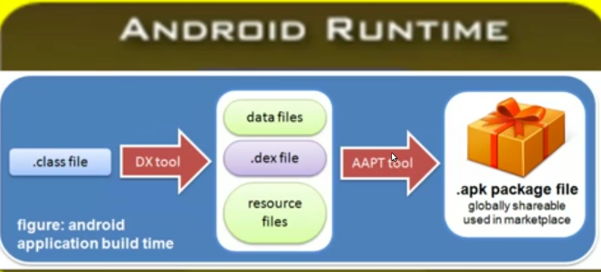
- Dex Compiler transforms .class bytecode into .dex bytecode for the Android Runtime (or Dalvik, for older versions of Android).
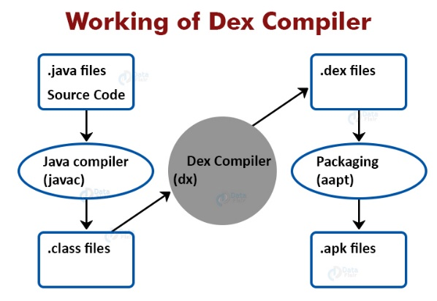

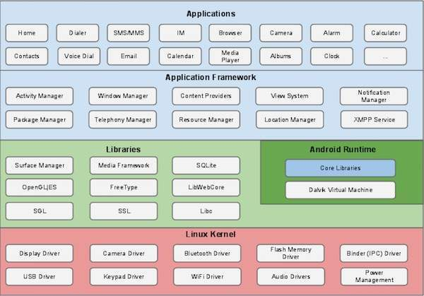
Managed by Activity Manager
- A single screen is known as Activity [Set of activities makes an app]
- User Interface [VIEWS] [Components]
- Any rectangular area that is clickable is a VIEW
- One screen owns a window at one time
Services without screen
- Donot require UI
- Toasts, Pop ups, ICONS on the top bar
Content Provider:
A Content Provider manages a shared set of app data. This shared set of data could be a file, an SQLite DB, a remote link to a web service, etc.
Broad cast receiver:
Receive and respond to the System wide announcements device turned on side, screen off, low battery, phone call incoming, etc.)
Intents: Message passing from one activity to another

